Add Board Descriptions SOP
This process is pretty straightforward. But since it's always a bit annoying to add them directly with every upload, I add them once a week (usually on Sundays).
- Open your Pinterest board.
- Click on the three dots at the top right > edit board.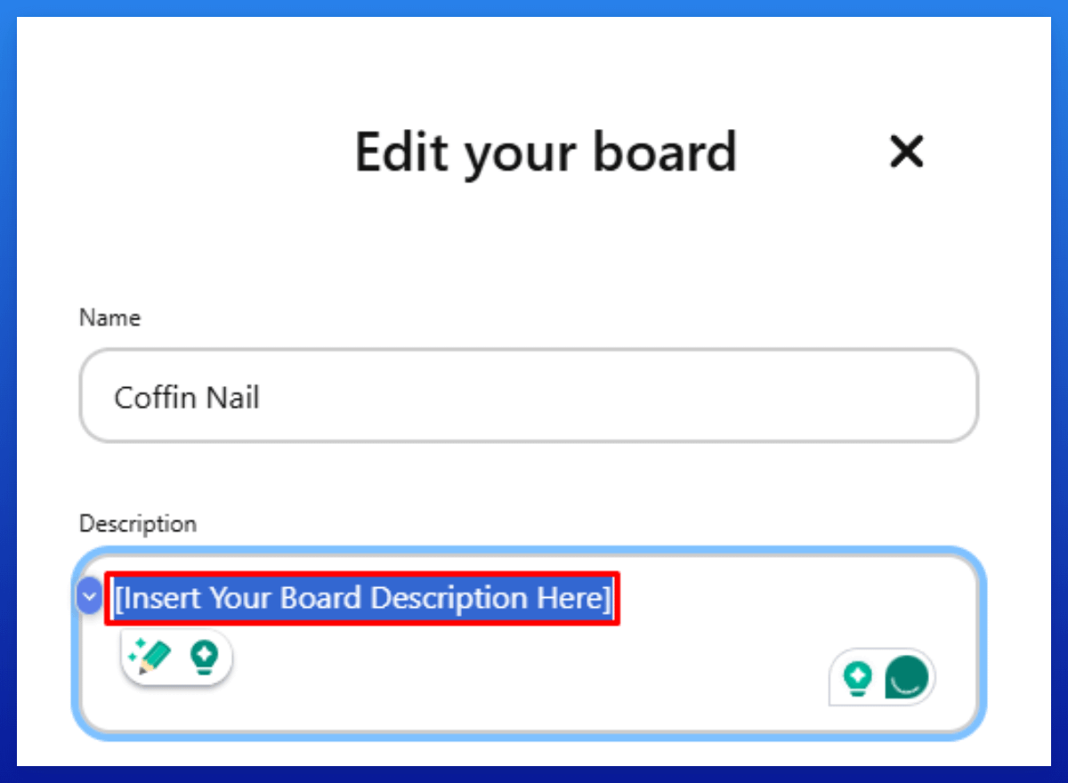
- Insert your board description from your overview sheet.

